Documentum
Content Server 6.5 sp2
Upgrade Guide

Revision History

Version Number | Date Updated | Revision Author | Brief Description of Changes
0.1 | 01-07-2010 | Sagar Golajana | Initial Version (Draft )

Table of Contents

1. INTRODUCTION..........................................................................................................................
2. Software Pre-Requisites……………………………………………………………………………….
2.1 Documentum Software………………………………………………………………………….......
2.1.1 Software Components &Versions……………………………………………………………
2.2 Assumptions…………………………………………………………………………………………..
3. Standard Product Installation…………………………………………………………….
3.1 Installation Pre-Requisites……………………………………………………………………………
3.1.1 Documentum Server Pre-Requisites…………………………………………………………..
3.1.2 Documentum Administrator Tomcat Instance…………………………………………………
3.1.3 Documentum Webtop Tomcat Instance……………………………………………………….
3.2 Backup & Restore Requirements…………………………………………………………………….
3.2.1 Backup Requirements…………………………………………………………………………….
3.2.2 Restore Requirements……………………………………………………………………………
3.3 External Software Pre-Requisites……………………………………………………………………………..
3.3.1 Required Oracle Instance ………………………………………………………………………………
3.3.2 Required Application Server instance………………………………………………………………….
3.3.3 Required HTTP Servers…………………………………………………………………………………
3.4 Content Server Upgrade……………………………………………………………………………………….
3.4.1 Pre-Requisites……………………………………………………………………………………………
3.4.2 Upgrade Preparation…………………………………………………………………………………….
3.4.3 Upgrading the Content Server files…………………………………………………………………….
3.4.4 Docbroker Upgrade……………………………………………………………………………………...
3.4.5 Docbase Upgrade………………………………………………………………………………………..
3.5 Documentum Administrator Installation…………………………………………………………………….....
3.5.1 Pre Requisites……………………………………………………………………………………………
3.5.2 Documentum Administrator Application upgradation Process……………………………………
3.5.3 Testing the Installation…………………………………………………………………………………
3.6 Documentum Webtop Installation……………………………………………………………………..............
3.6.1 Pre Requisites……………………………………………………………………………………………
3.6.2 Documentum Webtop Application upgradation Process…………………………………………….
3.6.3 Testing the Installation…………………………………………………………………………………
4. Documentum Team contact information………………………………………………………..........
5. Appendix 1 – Documentum products License Keys…………………………………………………

1 . Introduction:
This document provides a detailed guide to up gradation of Documentum 6.5 SP2 into the Production environment.

2. Software Pre-Requisites:
2.1 Documentum Software

2.1.1 Software Components & Versions
At time of the writing this document the following list of recommended Documentum Software versions. Documentum Server software required is as follows: -
- Documentum Content Server 6.5 SP2 (Solaris)
- Documentum Adminstrator 6.5 SP2 (Solaris)
- Documentum webtop 6.5 SP2 (Solaris)
2.2 Assumptions:

The following assumptions have been made: -
- The administrator performing the installation has pre-installed on their desktop either Exceed or XDeep/32 configured correctly to launch a XWindows session with the UNIX server.
3. Standard Product Installation
The following list details the required installation order.
- DFC 6.0 API upgrade in all External Apps
- Documentum Administrator Upgrade
- Webtop Upgrade
- Content Server & Docbase Upgrade

3.1 Installation Pre-Requisites
3.1.1 Documentum Server Pre-Requisites

Setting | Value | Description
Source Installation Files | Documentum\6.5 | The hostname of the server with the installation files.
Installation File Directory | /tmp/DCTMSoftware | The directory containing the source files required for installation.
Documentum Installation Owner | dmadmin | The user who has ownership of the installation files and own the running content server processes.
Documentum Installation Owner Password | <unknown> | The Password of the installation owner.
Docbase Name | <unknown> | Name of the docbase.
Docbase Owner Name | <unknown> | Used as the login to the RDBMS. Should also be configured at the OS level.
Database Server | <unknown> | The name of the oracle instance for the docbase.
Installation Directory | /tech/documentum | Target path to install Documentum too.
Content Server Host Name | <unknown> | Hostname the Content Server resides on.
Docbroker Hostname | <unknown> | Hostname of the docbroker.
Docbroker Port Number | 1489 | Port number the docbroker listens on.
Java Method Server Port Number | 9080 | The method server listens on this port number.
Java Method Server Shutdown Port Number | 9007 | Used to shutdown the method server.
Documentum Administrator URL | http://hostname:port/da | The URL to the Documentum Administrator instance.
Documentum WebTop URL | http://hostname:port/webtop | The URL to the Documentum Webtopinstance.

3.1.2 Documentum Administrator Tomcat Instance
3.1.3 Documentum Webtop Tomcat Instance
3.2 Backup & Restore Requirements
3.2.1 Backup Requirements
To backup the <Application Name> system the following needs to be done: -
- The Oracle indexes for the database <Application Name >hosted on the server ‘ <Server name> ’ have been re-indexed to ensure that there is no index fragmentation.
- Shutdown the <Application Name> Docbase by performing the following steps: -
- Login into the server ‘Host Error: Reference source not found’ with the following user credentials using ssh: -
  - Username: Error: Reference source not found
  - Password: Error: Reference source not found
- At the command prompted execute the command ‘$DOCUMENTUM/dba/dm_shutdown_<Docbase name>’.
- A full backup of the <Application Name > database this includes both its table-space and index-space. Using the standard Oracle tools, or preferred backup tool.
- A full backup on the filesystem of the following Documentum paths: -
    - Error: Reference source not found

3.2.2 Restore Requirements
Should the decision be made to back out the upgrade process then the following must be done.
- Completely restore the Application Name database replacing the existing one on ‘ServerName’. Using the standard Oracle tools, or preferred backup tool.
- Delete the contents of Error: Reference source not found
- Restore the backups of the file-system to the respective locations they were taken from these are as follows: -
    - Error: Reference source not found
- The Documentum Services should then be restarted.
- External Software Pre-Requisites
The following sections detail the software components that must installed and configured before starting the installation process

3.3 External Software Pre-Requisites
3.3.1 Required Oracle Instance
Prior to commencement of installation one oracle instances should be pre-configured with support for the Oracle DBA .
3.3.2 Required Application Server instance
3. 3. 3 Required HTTP Servers
3.4 Content Server Upgrade
The following sections provide a detailed breakdown of the required steps for upgrading the existing Documentum 5.3 SP2 installation to Documentum 6.5 SP2 in the Production for <Application Name>
    - Pre-Requisites
The pre-requisites defined in the Installation guide should be met. In summary the following pre-requisites should be set: -
- The installation must be performed using a XServer tool (Such as Exceed or XDeep/32) is running to enable remote desktop.
- The oracle client libraries are installed and correctly configured.
- A port mapping must be added to /etc/services on the server <ServerName>the entry must be as follows: -

- The following environment variables must be set in the profile of the Error: Reference source not found account: -
DOCUMENTUM=Error: Reference source not found
DM_HOME=$DOCUMENTUM/product/6.5
DOCUMENTUM_SHARED=$DOCUMENTUM
ORACLE_BASE=/usr/local/oracle
ORACLE_HOME=$ORACLE_BASE/product/9207
PATH=$ORACLE_HOME/bin:/usr/local/bin:/usr/openwin/bin:$PATH
LD_LIBRARY_PATH=$ORACLE_HOME/lib:$DOCUMENTUM_SHARED/dfc:$DM_HOME/bin
TNS_ADMIN=$ORACLE_HOME/network/admin
ORA_NLS10=$ORACLE_HOME/nls/data
ORACLE_OWNER=oracle
LC_ALL=C

    - Upgrade Preparation
- Open a new instance of Internet Explorer and enter the url ‘Error: Reference source not found’ into the address bar.
- Press ‘Enter’.
- At the login prompt enter the following user details: -
  - Username:Error: Reference source not found
  - Password: Error: Reference source not found
- On the left hand side tree view expand the option ‘Jobs Management’.
- Click the option ‘Jobs’.
- In the top right hand side, under the option ‘Show Items’ select the ‘100’ option.
- Scroll down the list until you see the job name ‘dm_RenditionMgt’. Select the check box next to it. Note the date/time stamp in the column marked ‘Last Run’.
- From the menu along the top select the option ‘Tools->Run’ the page will refresh.
- Wait for a minute and select ‘View->Refresh’. If the date/time stamp in the column remains the same and/or the status does not change to ‘Running’ escalate the problem.
If the state changes to ‘Running’ then repeat this step until the ‘Last Run’ date is updated and the state changes back from Running.
- Once complete, highlight the job ‘dm_RenditionMgt’ by selecting the checkbox next to it.
- Select from the menu options ‘View->Report’ and confirm there are no errors present.
If errors are present then escalate this the problem .
- Steps 6 – 11 must be repeated for the following jobs: -
NB. Some of these jobs may take some time to be executed.
The jobs must be executed in the following order: -
- dm_RenditionMgt
- dm_VersionMgt
- dm_GWMClean
- dm_DataDictionaryPublisher
- dm_LogPurge
- dm_DMClean
- dm_AuditMgt
- dm_UpdateStats
- dm_DBWarning
- dm_DMFilescan
- dm_StateOfDocbase
- If all of the above steps are complete then please ensure that all of the Documentum services are shutdown, by executing the following scripts as the user ‘Error: Reference source not found’.
  - $DOCUMENTUM/dba/dm_shutdown_<DocbaseName>
  - $DOCUMENTUM/dba/dm_stop_docbroker
  - $DM_HOME/tomcat/bin/shutdown.sh
- Once the jobs have been completed, then a backup must take place: -
- The Oracle indexes for the database <Application Name > have been re-indexed to ensure that there is no index fragmentation.
- Shutdown the Docbase by performing the following steps: -
- Login into the server ‘ServerName’ with the following user credentials using ssh: -
  - Username:<unknown>
  - Password:Error: Reference source not found
- At the command prompted execute the command ‘$DOCUMENTUM/dba/dm_shutdown_<DocbaseName>’.
- A full backup of the <ApplicationName>database this includes both its table-space and index-space. Using the standard Oracle tools, or preferred backup tool.
- A full backup on the filesystem of the following Documentum paths: -
Error: Reference source not found
    - Upgrading the Content Server files
- Login into the server ‘ServerName’ with the following user credentials using Exceed: -
  - Username: <unknown>
  - Password: Error: Reference source not found
- Ensure that all of the pre-requisites have been met as defined in previous section
- Ensure that all of the preparation steps have been met as detailed in the previous section.
- All Documentum services are shutdown; to shutdown the servers execute the following scripts as user Error: Reference source not found.
  - $DOCUMENTUM/dba/dm_shutdown_<DocbaseName>
  - $DOCUMENTUM/dba/dm_stop_docbroker
  - $DM_HOME/tomcat/bin/shutdown.sh
- Edit the users ‘.profile’ for Error: Reference source not found and modify the setting of the environment variable DM_HOME too: -
$DOCUMENTUM/product/6.5
Replacing: -
$DOCUMENTUM/product/5.3
For the upgrade process this is too ensure that the Content Server binaries do not over-write the previous installation.
- Once the changes have been made then please log out.
- Login into the server ‘ServerName’ with the following user credentials using Exceed: -
  - Username: Error: Reference source not found
  - Password: Error: Reference source not found
- Type the command ‘echo $DM_HOME’ and confirm the environment variable is set too: -
Error: Reference source not found/product/6.5
If this is not the case then please return to step 5.
- Execute the command ‘cd /tmp’
- Execute the command ‘mkdir cs_install’
- Copy the file ‘Content_Server_6.5_SP2_solaris_oracle.tar’ from the directory ‘Error: Reference source not found’ from the server ‘ServerName’ to ‘/tmp/cs_install’.
- Execute the command ‘cd /tmp/cs_install’.
- Execute the command ‘tar –xvf Content_Server_5.3_SP2_solaris_oracle.tar’.
- Execute the script from the command line ‘./serverSolSuiteSetup.bin’.
- Welcome screen, click next.
- Accept the license agreement.
- Ensure that the checkbox for ‘developer documentation’ is not selected.
- Select ‘Next’
- Select Enable TCS.
- In the TCS License key field enter ‘<unknown>’.
- Click Next
- Prompted for method server ports
- Ensure that the checkbox for ‘Content Services for EMC Centera’ is not selected.
- Enter the target installation directory ‘Error: Reference source not found’. (Note: This should be taken from the environment variables so you will not be prompted for this)
- The user is asked to confirm the selection, just clicked next.
- When prompted to set BOF Global Repository Settings, make sure it is selected.
- Select ‘Configure Server Later’ and click next.
- Click finish.

    - Docbroker Upgrade
- Login into the server ‘ServerName’ with the following user credentials using Exceed: -
  - Username: Error: Reference source not found
  - Password: Error: Reference source not found
- Ensure that the steps in section Error: Reference source not found page Error: Reference source not found have been successfully completed.
- All Documentum services are shutdown; to shutdown the servers execute the following scripts as user Error: Reference source not found.
  - $DOCUMENTUM/dba/dm_shutdown_<DocbaseName>
  - $DOCUMENTUM/dba/dm_stop_docbroker
  - $DM_HOME/tomcat/bin/shutdown.sh
- Type ‘cd $DM_HOME/install’.
- Execute the following script ‘./dm_launch_server_config_program.sh’
- You are presented with the welcome screen.
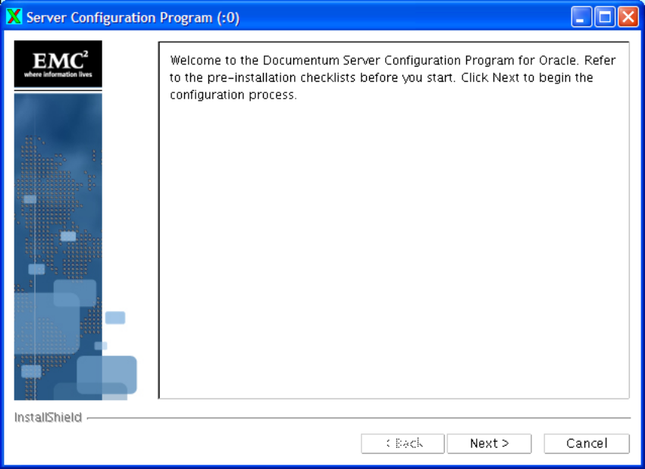
- Click ‘Next’.
- You are then prompted if you want to enable ‘Content Services for EMC Centera’.
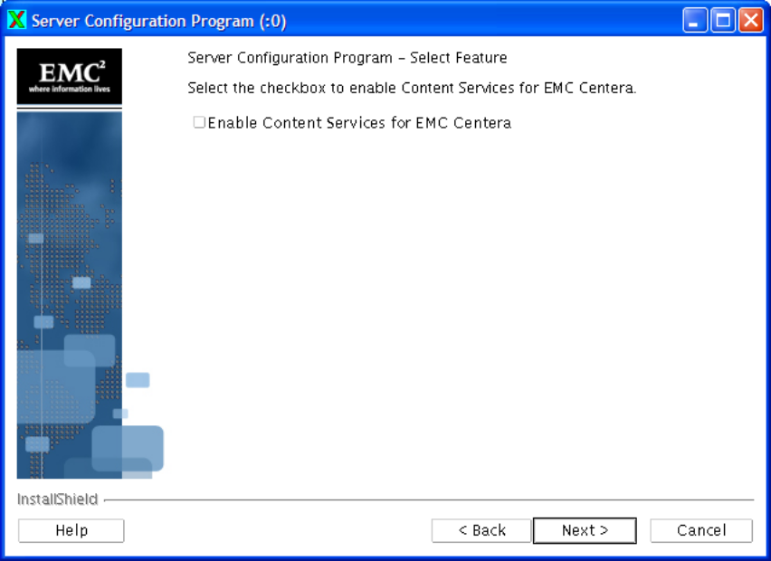
  - Ensure that the checkbox for ‘Content Services for EMC Centera’ is not selected.
- Click ‘Next’.
- You are then prompted to select configuration type.
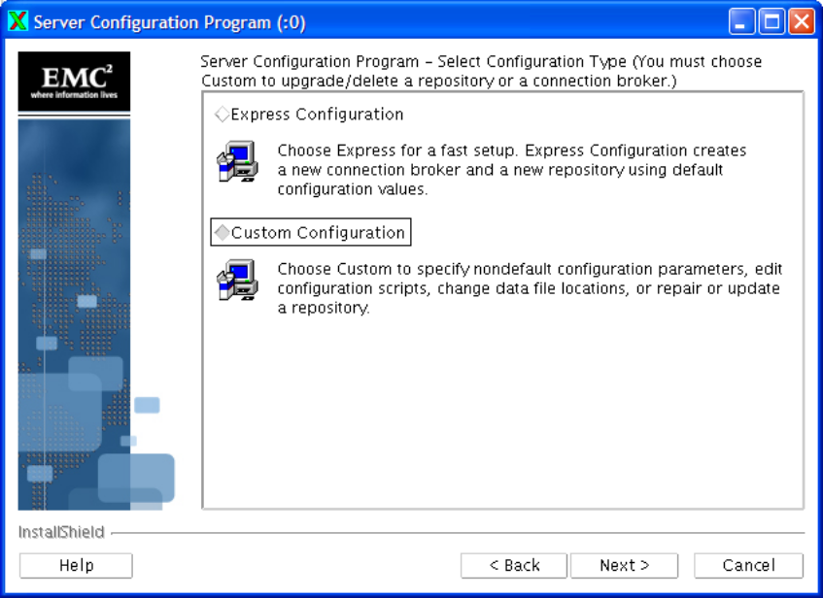
  - Select ‘Custom Configuration’.
- Click ‘Next’.
- Next you are prompted what you want to configure.
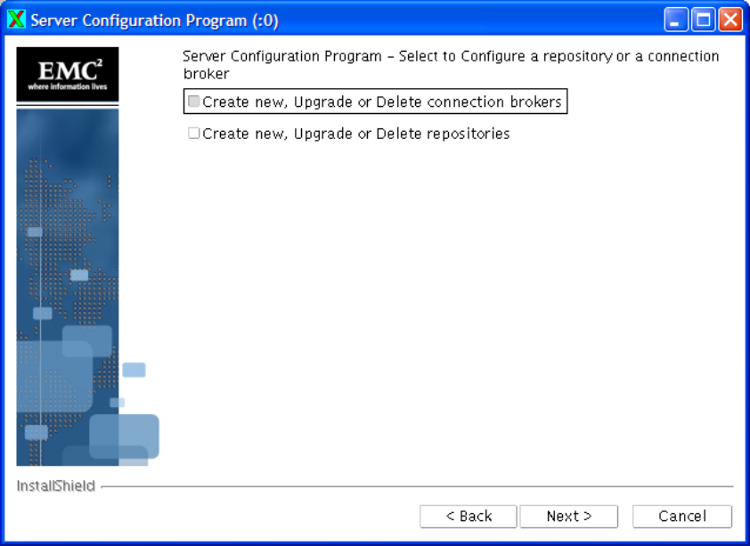
  - Select ‘Create new, Upgrade or Delete connection brokers’.
- Click ‘Next’.
- You are next prompted to select the appropriate action.
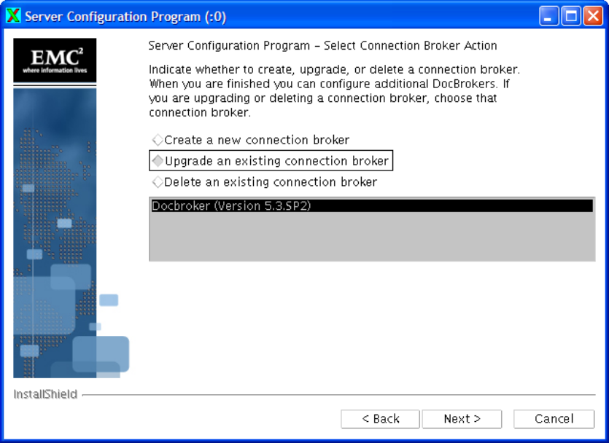
  - Select ‘Upgrade an existing Connection Broker’.
  - Select the ‘Docbroker 5.3 sp2’.
- Click ‘Next’.
- Click ‘Ok’ to upgrade the Docbroker.
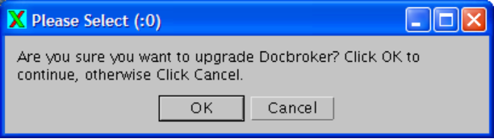
- Wait while the docbroker is upgraded.
- You are then prompted if you want configure an additional connection broker.
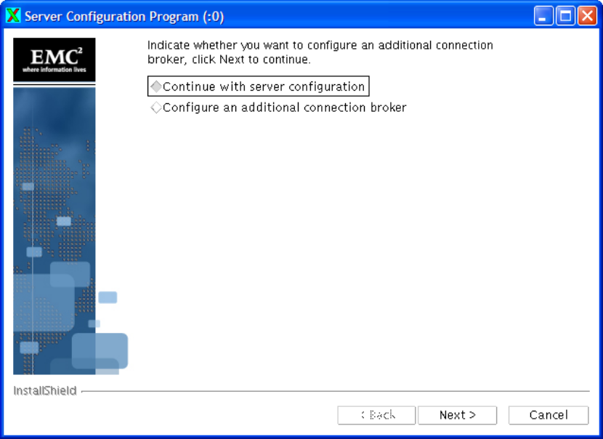
  - Make sure ‘Continue with the server configuration’ is checked.
- Click ‘Next’.
- You are then presented with a confirmation of the tasks completed.
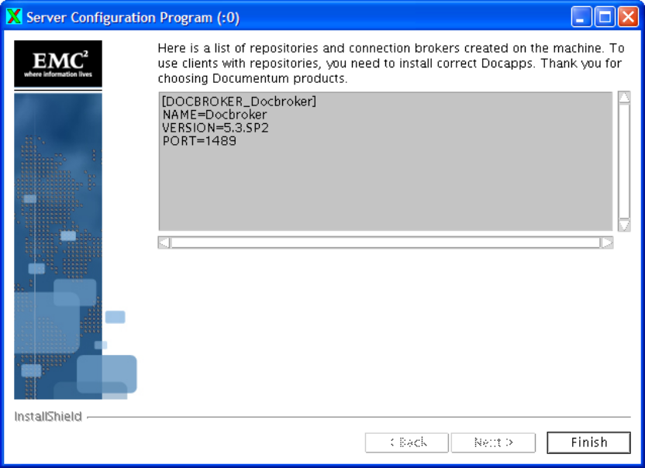
- Click ‘Finish’.

    - Docbase Upgrade
- Login into the server ‘ServerName’ with the following user credentials using Exceed: -
  - Username: <unknown>
  - Password: Error: Reference source not found
- Ensure that the steps in section Error: Reference source not found on page Error: Reference source not found have been successfully completed.
- Ensure that the steps in section Error: Reference source not found on page Error: Reference source not found have been successfully completed.
- Check the docbroker is running by executing the command ‘ps –ef docbroker’.
The process ‘./dmdocbroker -port 1489’ should be listed. If it is not then complete the following steps: -
  - Execute the command ‘cd $DOCUMENTUM/dba’.
  - Execute the command ‘nohup ./dm_launch_Docbroker’
- Ensure the following entries are in the file ‘/etc/services’: -
(Ports needs to be configured as per application)
- Type ‘cd $DM_HOME/install’.
- Execute the following script ‘./dm_launch_server_config_program.sh’
- You are presented with the welcome screen.
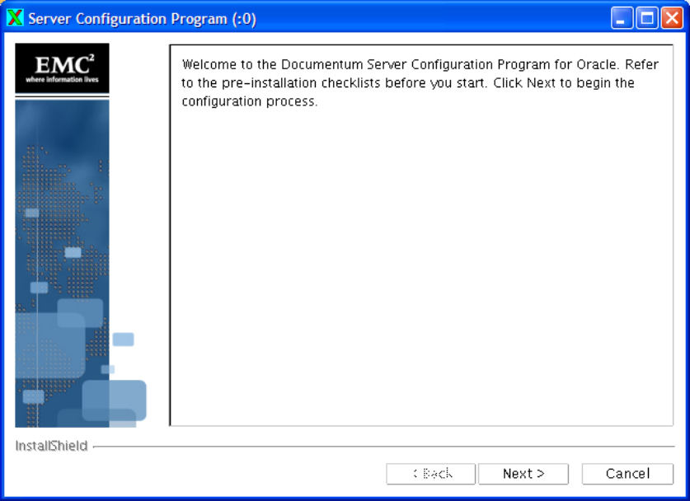
- Click ‘Next’.
- You are prompted to enable ‘Content Services for EMC Centera’.
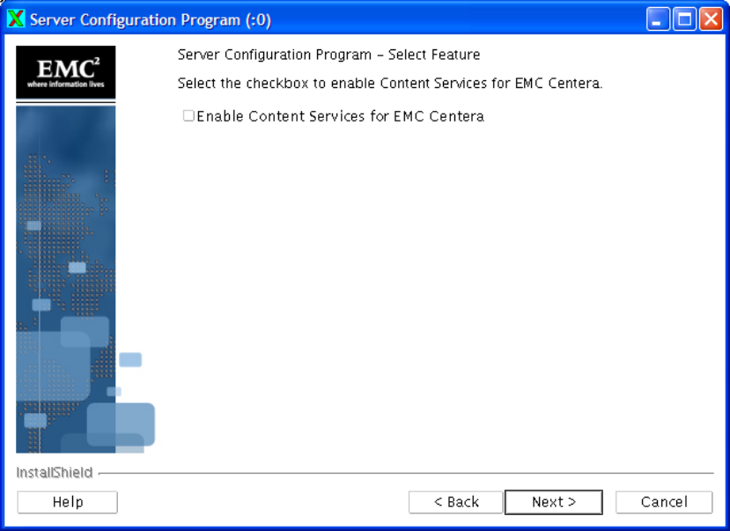
  - Do not check the option ‘Enable Content Services for EMC Centera’.
- Click ‘Next’.
- You are prompted to select the configuration type.
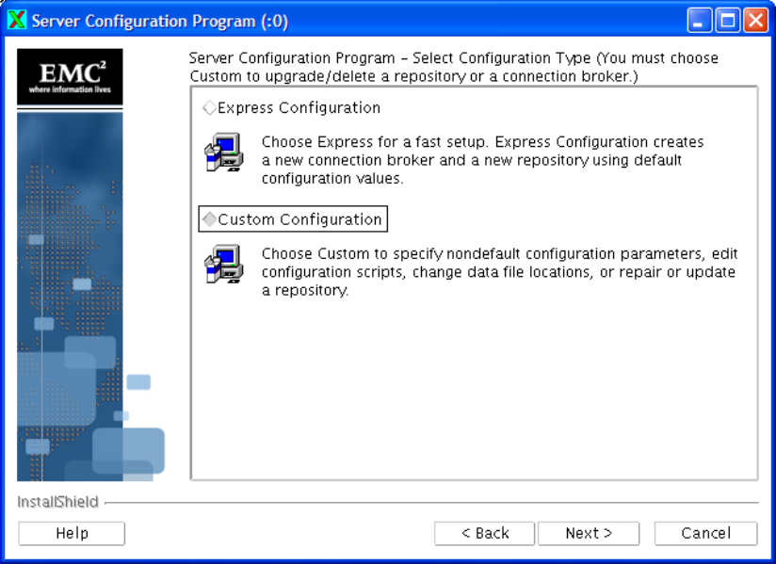
  - Select ‘Custom Configuration’.
- Click ‘Next’.
- Next you are prompted to configure a repository or connection broker.
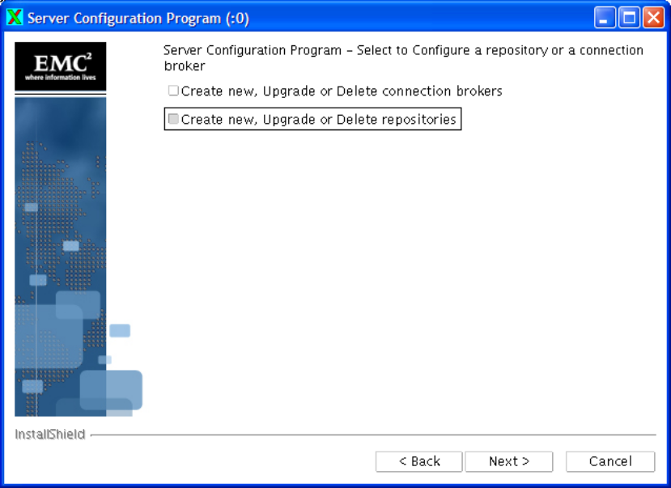
  - Click ‘Create new, Upgrade or Delete repositories’.
- Click ‘Next’.
- You are prompted to select a repository action
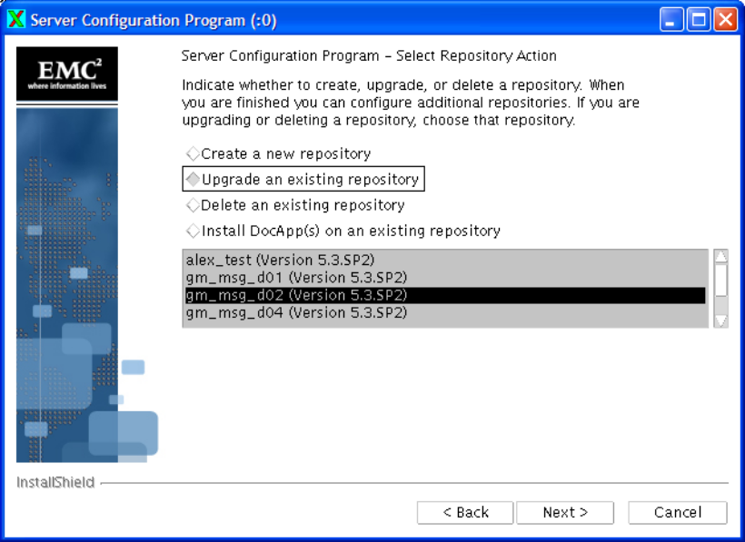
  - Select ‘Upgrade an existing repository’.
  - Select ‘<DocbaseName 5.3 SP2’. From the list box.
- Click ‘Next’.
- Click ‘Ok’ to confirm the upgrade.

- Next you are prompted to select Content Storage Services.
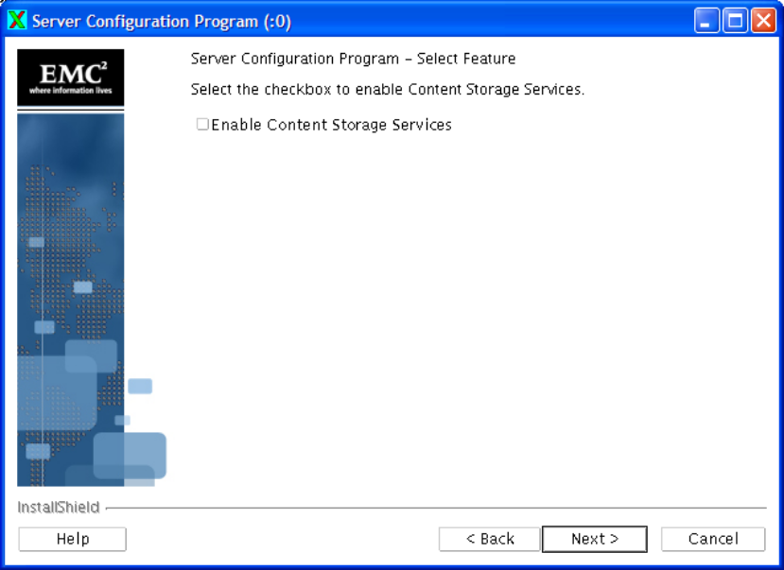
  - Make sure ‘Enable Content Storage Services’ is not checked.
- Click ‘Next’.
- You are prompted to enable collaborative edition.
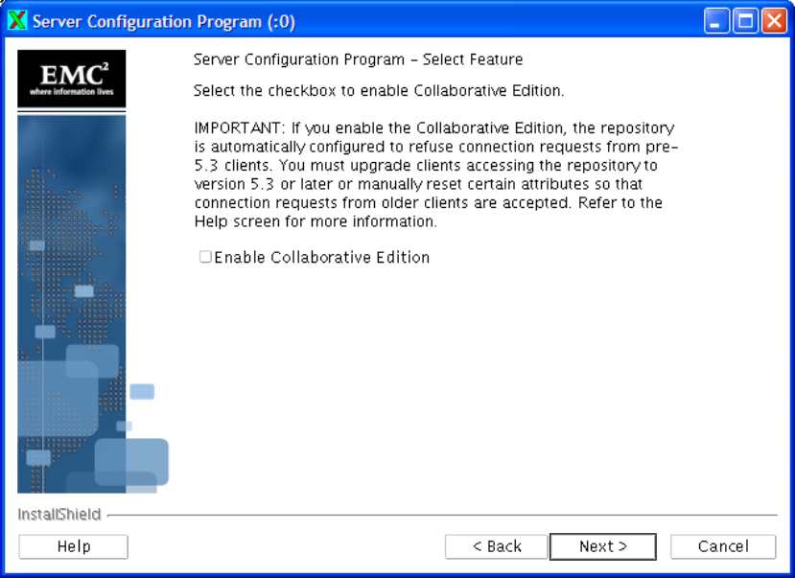
  - Do not select ‘Enable Collaborative Edition’.
- Click ‘Next’.
- You are prompted to enable retention policy services.
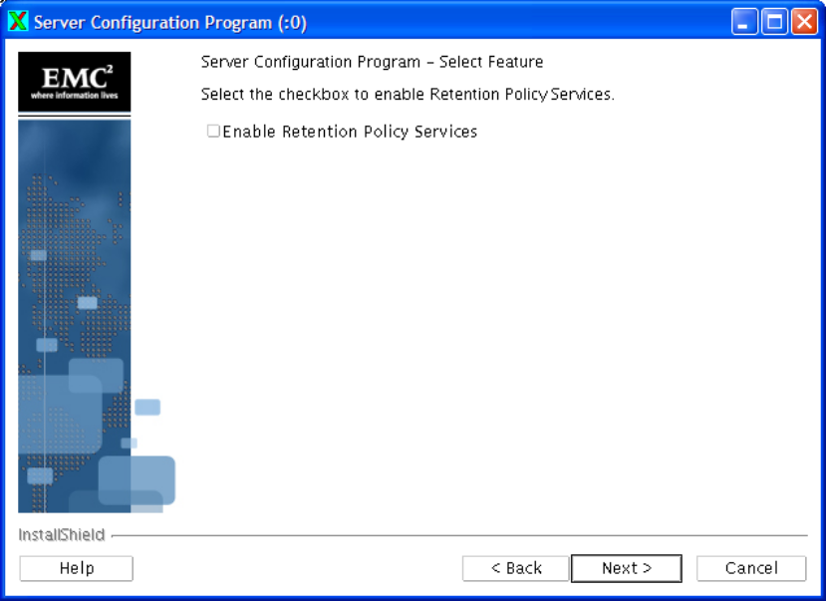
  - Do not select ‘Enable Retention Policy Services’.
- The installer will then perform some validation checks.

- You are then prompted to confirm the docbroker settings, which should already be populated.
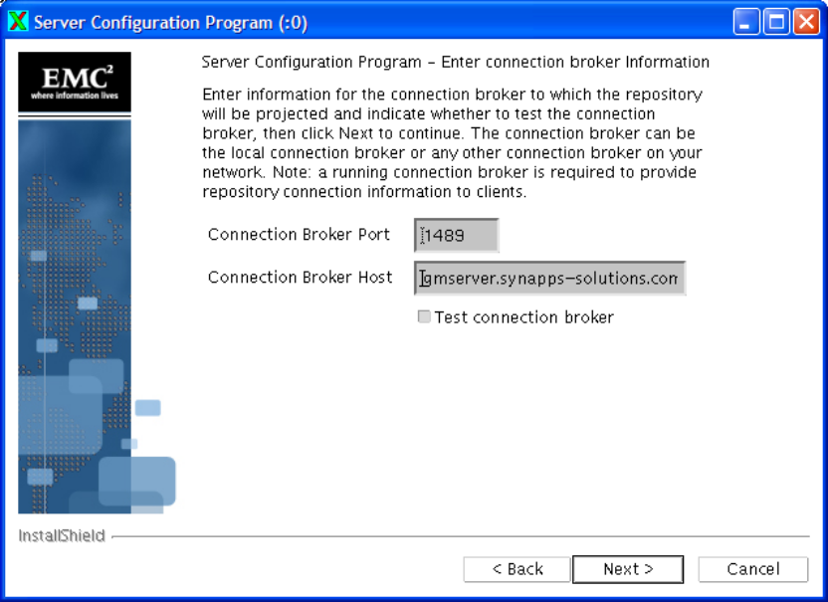
  - Make sure the Connection Broker Port is: Error: Reference source not found
  - Make sure the Connection Broker Host is: DocbrokerHostname .
  - Make sure ‘Test Docbroker connection’ is checked.
- Click ‘Next’.
- If the test docbroker connection fails, then please escalate the issue.
If no error is reported then continue with the next steps.
- You are then prompted for the connection type.
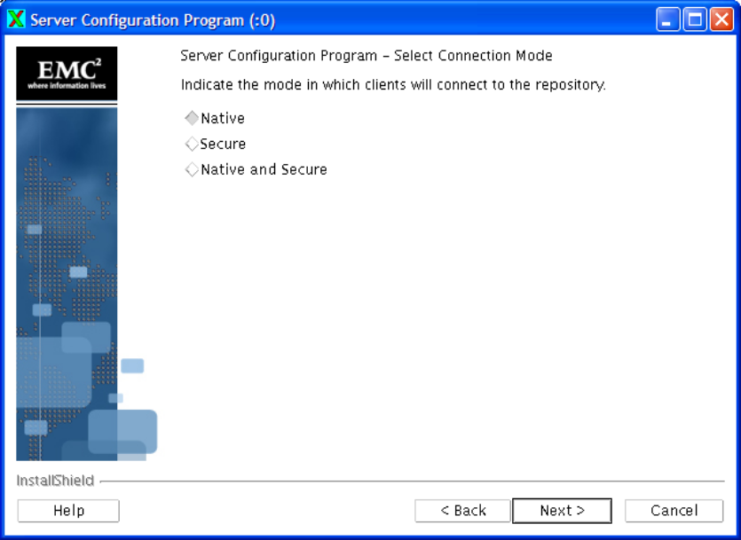
  - Make sure ‘Native’ is selected.
- Click ‘Next’.
- Some additional validation is performed.
- You are then prompted to edit the server initialisation files.
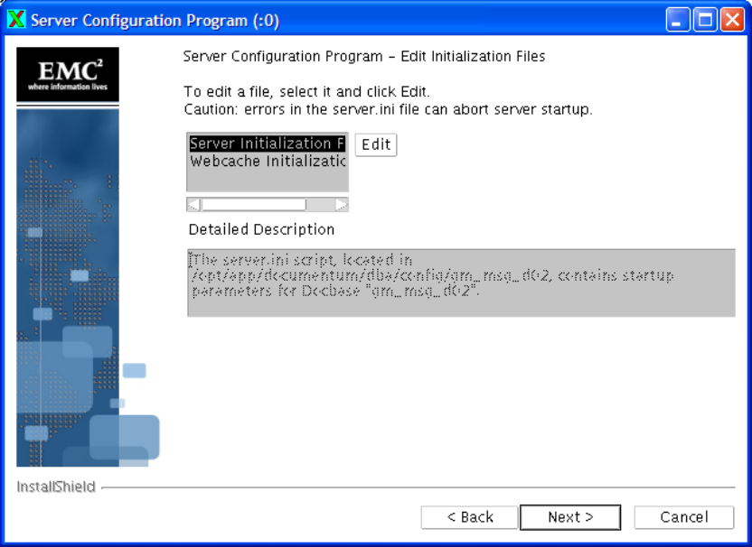
- Click ‘Next’.
- Please wait for the content server to start, this may take some time.
- If you get the prompt ‘Fail to connect to the Repository, it could be that server is in the progress of starting’, please escalate the issue.
NB. This is a critical point in the upgrade process
- Providing all goes well, you will be prompted to ‘Edit the installation scripts’.
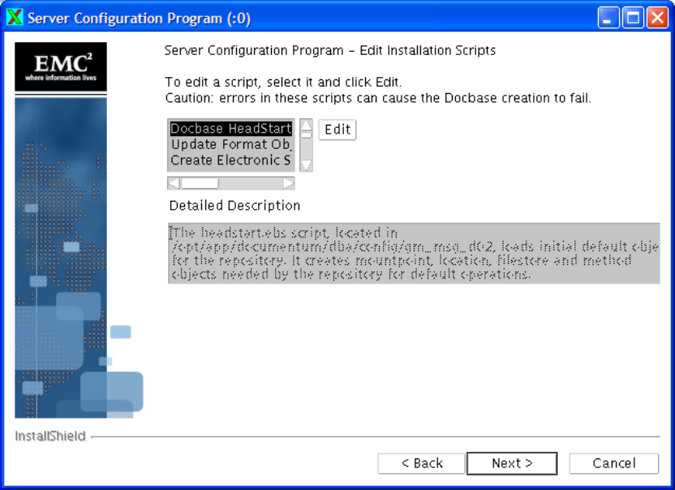
- Click ‘Next’.
- You will be presented with another progress bar while the repository is pre-configured.
- NB. If any errors are reported then please escalate this issue.
- You should get a successful message, click ‘Next’.
- You may be prompted to install some docapps
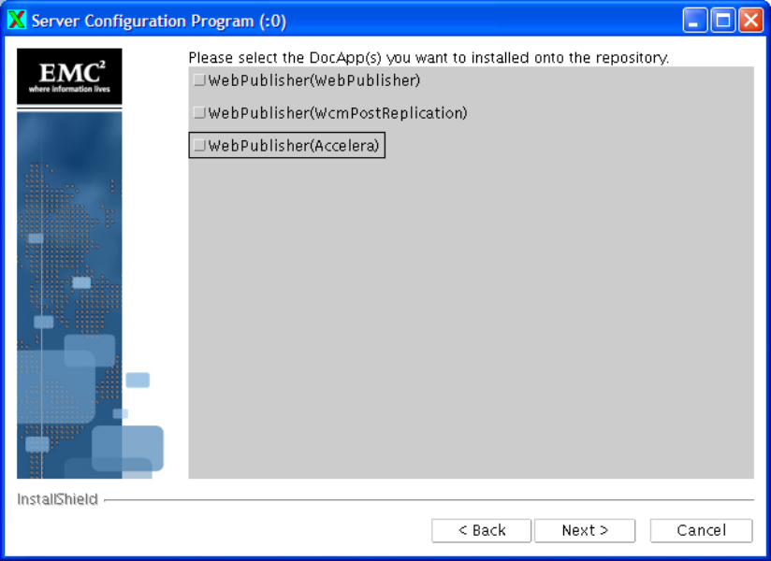
  - If you then deselect them all, and click ‘Next’.
- You are then prompted to Configure More Components
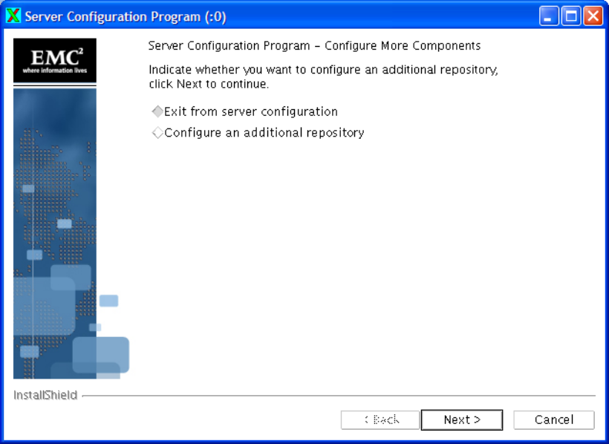
  - Select ‘Exit from server configuration’
- Click ‘Next’.
- You are then presented with a confirmation screen
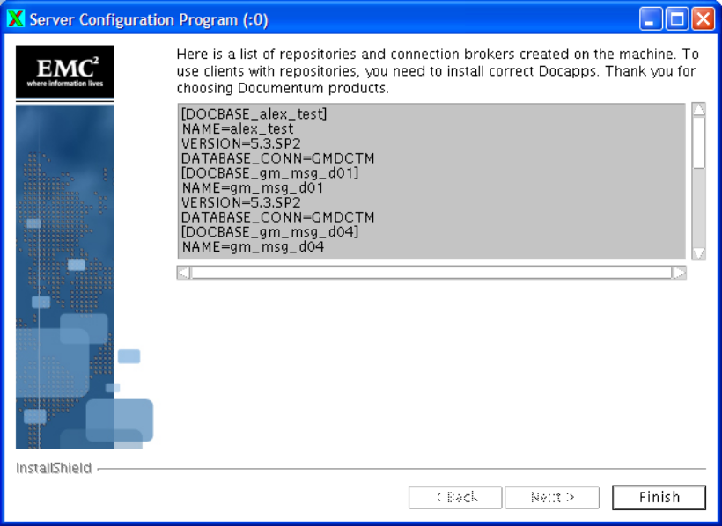
- Click ‘Finish’
The docbase should now be successfully installed and running.

